Petersburg Reconnaissance April 2010
By David Lowe and Philip Shiman

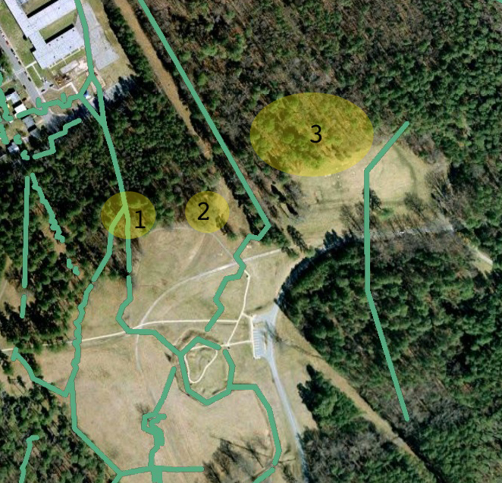
David Lowe of the National Park Service with Dr. Philip Shiman spent three days examining earthworks within the Eastern Front unit of Petersburg National Battlefield Park, assisted and accompanied for part of the time by James Blankenship. The purpose of this recon was to test a GIS map overlay derived from the manuscript map of the area downloaded from the Library of Congress website (cw0607200). We also hoped to definitively locate photographs of the fortifications that have resisted identification. The map overlay proved highly accurate for the features depicted. The jury is still out on some of the photographs in question, although we made progress. The purpose of this trip report is to share some of our observations with those at the park and other interested parties.

North of Fort Stedman
The manuscript map shows only the front Union line in this area. For the illustration below I added the oblique line that led from the north angle of the fort to the old Court House Road and a partial line to the east that likely dated from June 16, 1864, from a previous overlay of the Michler 1867 maps. The oblique line is no longer visible. A parapet does extend north along the Court House Road, where segments vary in condition. The intersection of trenches shown on the manuscript map survives (1), the out-going trench in surprisingly good condition. At (2) there appears to be an artillery lunette. This feature may be a remnant of an intermediate line that was afterwards largely demolished as it does appear on several Union maps from July 1864. At (3) there is a military road and an extensive complex of what appear to have been bunkers and covered ways. As it turns out, this is a military road but it dates from World War I, when Fort Lee expanded into the park. A period map shows rows of long buildings, perhaps, barracks in this area, but no evidence survives above ground.

Fort Stedman
Two photos, long identified, depict the front faces of Fort Stedman (stereograph 00540 and Gardner Sketchbook plate 74); the first looks from the northernmost parapet toward the southwest; Fort Haskell appears in the distance in the left center; the second looks toward the north along the western face from a traverse on the southwest face of the fort. Both photos focus on the “fighting faces” of the fort, showing gun platforms and protective artillery mantelets.

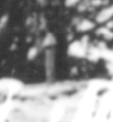
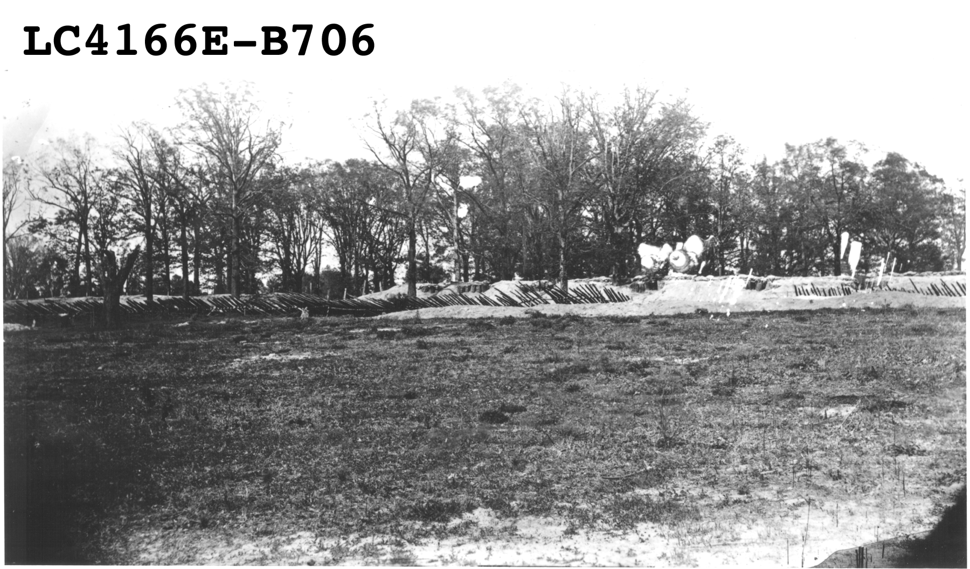
A third print from the Library of Congress, not widely identified, shows Fort Stedman from the outside looking in (Print Lot 4166E-B706) from about 50 yards outside the fort. The LC print had not been digitized or catalogued at the time of this writing. Another print of the same photo from the USAMHI has recently been put online, correctly identified as “Fort Stedman.” An interesting detail from this image shows the distinctive aeration pipe and cap (below right) that appear in the first two Stedman photos The camera location for this image was identified to within a few feet.

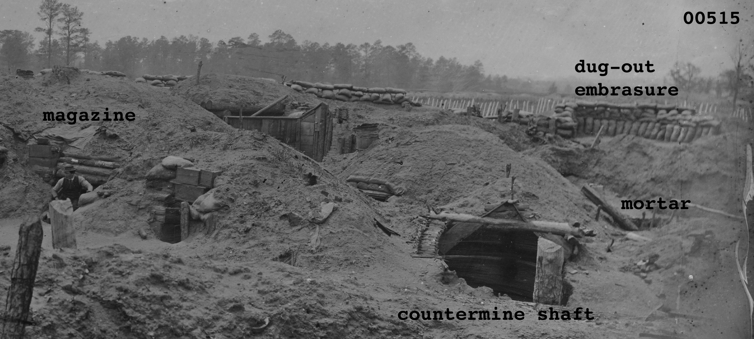
A number of photos are purported to be taken from the “interior of Fort Stedman,” including 00531, 02852/02853, 02854/02855, and 3c27679. Each of these images shows bombproofs arranged in a distinctive gallery with stacked brick chimneys and piers. The bricks likely came from the nearby Hare House, gradually dismantled as the siege persisted. It is likely that three of the four were taken inside the fort, using the period equivalent of a fisheye lens. A fourth photo does not seem to match the fort interior.

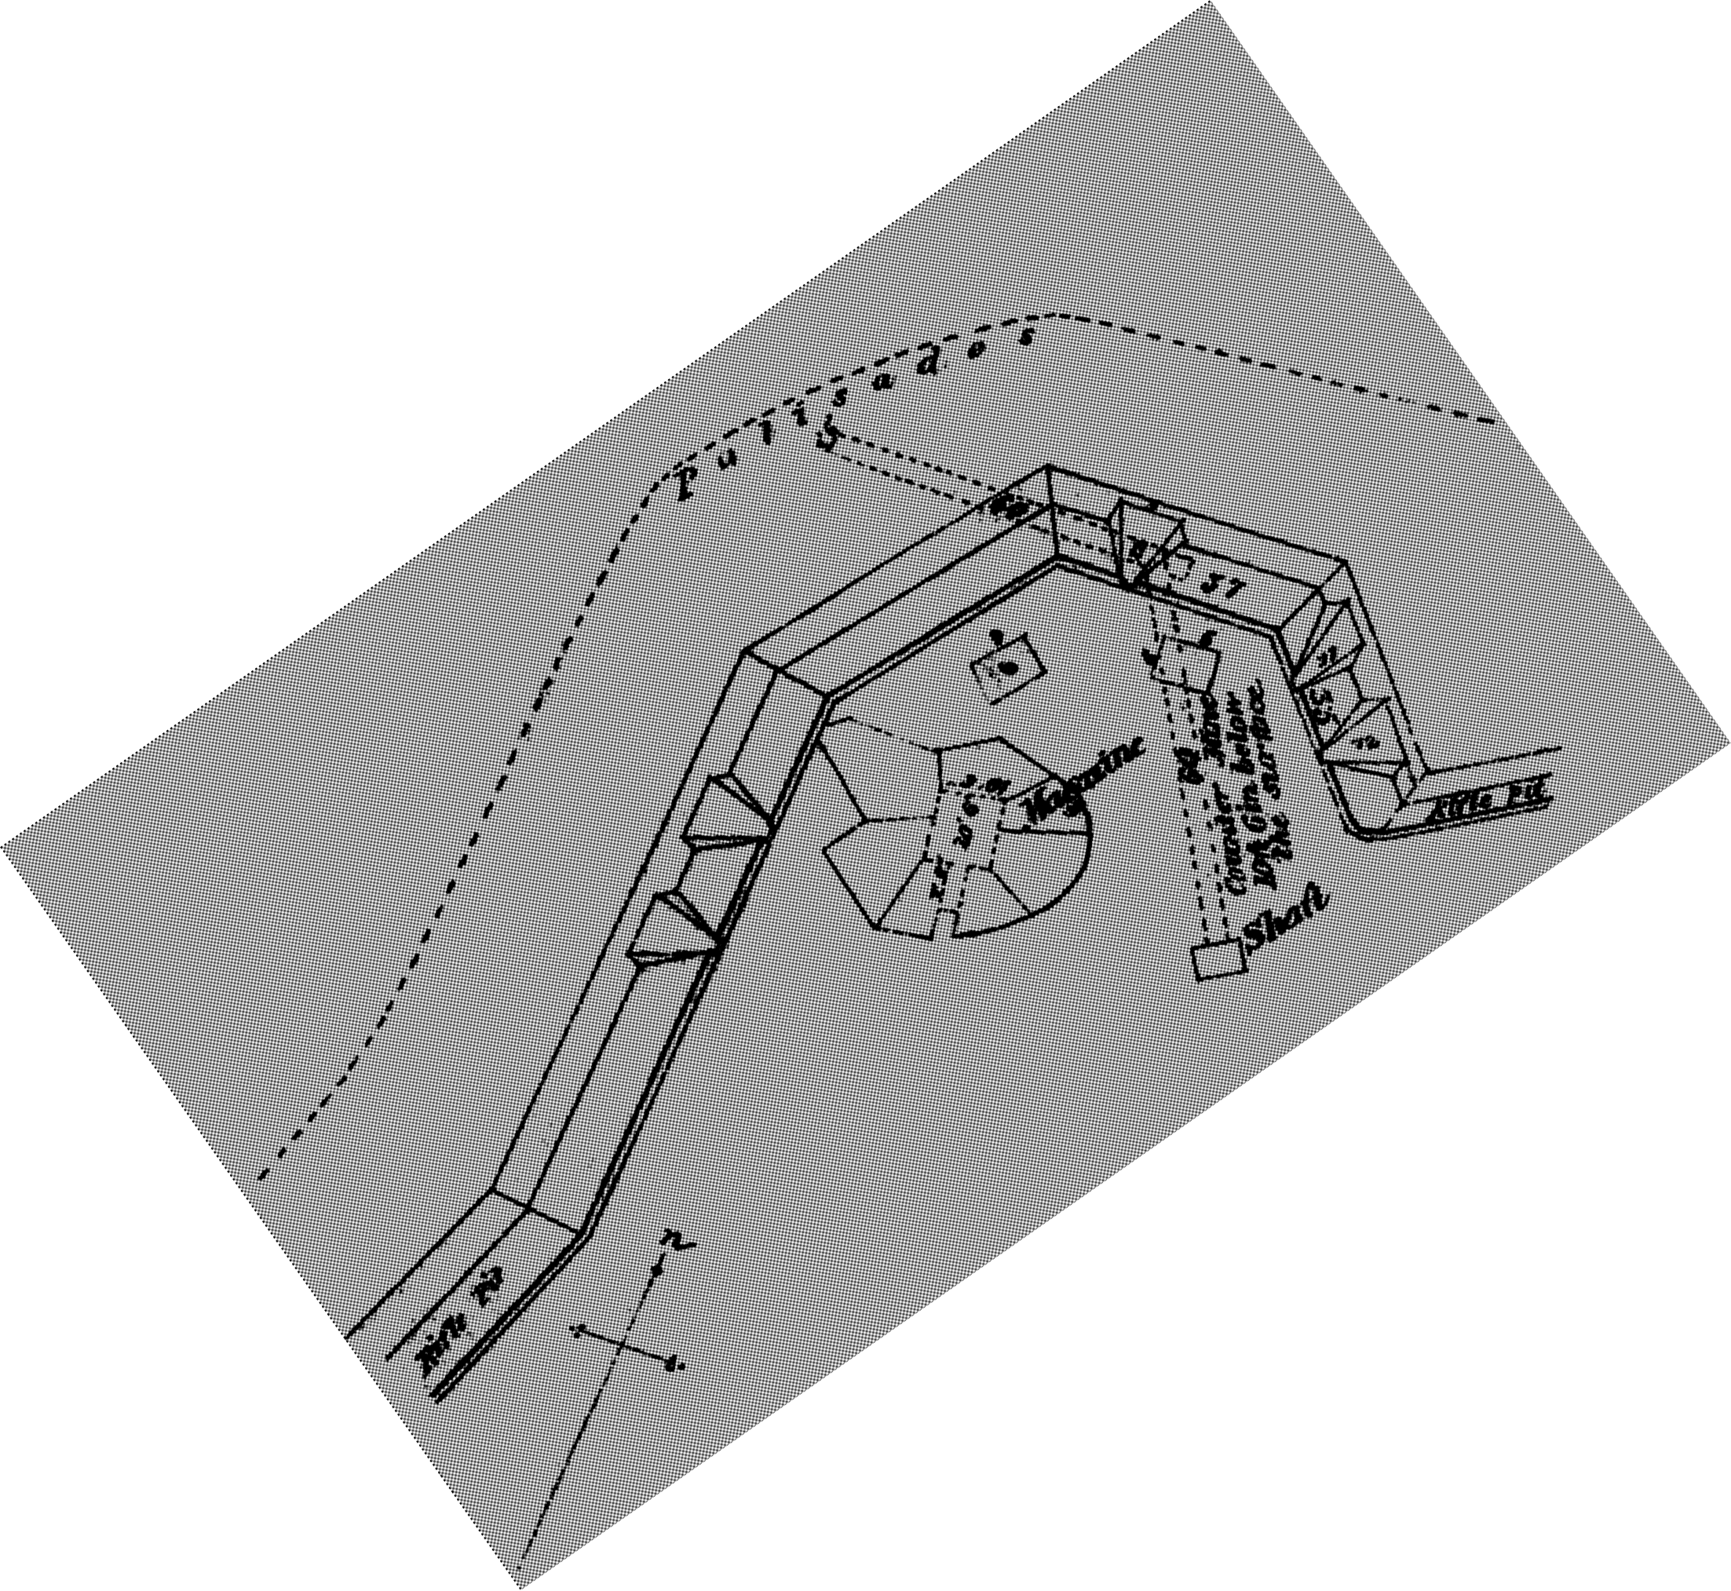
Stereo view 00515 was taken from the rear of Battery X likely from the point where the oblique line (in the foreground) diverged from the fort. The identity of the photo is confirmed by correspondences between key features and the engineer’s plan for Battery X, including the main bombproof, and the entrance to the shaft of the countermine. A second, makeshift bombproof that does not appear on the plan, was built to the right of the main magazine and revetted by ammo boxes. The merlon between the two embrasures in the front salient angle of the fort was dug out, likely during the fighting of March 25, and afterwards repaired with sandbags.
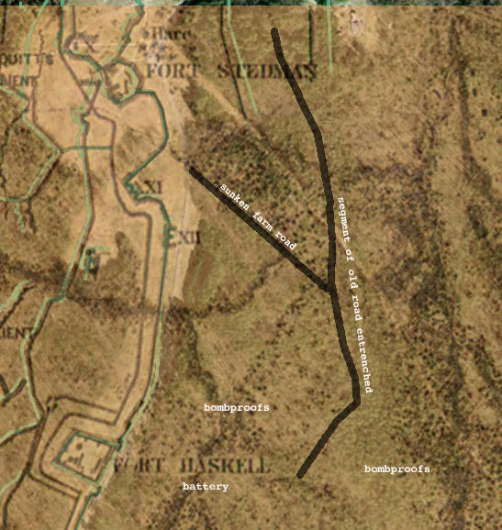
East of the Tour Road
The woods east of the tour road and south of Fort Stedman hold many interesting features, most of which relate to the fighting in mid-June 1864. Running obliquely downhill from behind Battery XI is a sunken farm road that bears signs of digging all along its northern berm, likely representing a large number of smaller bombproofs built for personal shelter. This farm road shows up in two photographs (00532 and 00516). Besides descending the hill at the same grade, several bombproofs or other details along the road can be correlated between the two photos. A large part of the Confederate June 16 line in these woods has not been traced out or mapped—the sector fell between two corps at the time and thus does not appear on any of the historic maps.

Fort Haskell
Among the most important of our photo identifications are three views taken from within Fort Haskell (01324/01325, 01326, and 00532).
Gracie’s Salient and Colquitt’s Salient
Gracie’s Salient and the southern portion of Colquitt’s are among the best-documented areas in the park by map and by photograph. At least thirteen images, including nine stereographs, taken by Timothy O’Sullivan, have been identified. These are Library of Congress image numbers 12607, 03644, 01322, 03624, 00514, 00520, 00521, 00522, 00523, 00524, 00526, and 00528. Distinct details can be linked from image to image. This fact, coupled with the extensive surviving earthworks, offers great interpretive potential for this area.

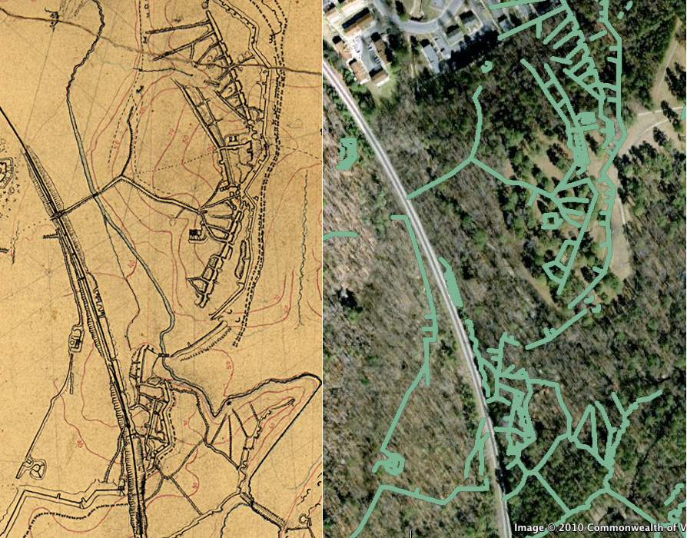
The illustration below shows Gracie’s and Colquitt’s inside the park. On the left is a detail from the manuscript map, where the cartographer took great pains to represent the extent and character of the excavations. A Google Earth overlay of the same area is on the right. Most of the earthworks (east of the railroad, at least) appear to survive in decent condition. Land use west of the railroad has differed significantly and the resources have suffered; earthworks here can be traced with map in hand but are in poor condition.

We were able to identify approximate camera locations for all of the Gracie/Colquitt photographs and are confident that when the vegetation is down we could place these photos fairly precisely, thereby allowing us to match specific resources with photographic details. This would require better modern mapping of these resources than currently exists.

Three photographs from slightly different camera angles (00522, 00523, and 00524) were taken from Gracie’s Salient in the foreground looking north over Poor Creek into Colquitt’s Salient. The massive double wall and maze of bombproofs in Colquitt’s is readily recognizable on the ground today and should be examined, measured, and mapped in detail in winter when visibility improves and eagle restrictions are suspended.

These photos were probably taken in reverse order of the LOC numbering, as the original negative numbers scratched into the emulsion were 376, 377, and 378. The camera position for 00524 was on or adjacent to the railroad cut, the view to the northeast toward Colquitt’s with Fort Stedman and Battery X visible in the right-hand stereo pair in the background. Subsequently, the camera was moved atop the parapet in the foreground for 00523, then down the slope to look into the ravine. 00524 captures the Poor Creek Dam on the left at the base of the slope. The dam survives intact as do most of the earthworks this side of the railroad cut. Image 01320 offers a glimpse of Fort Haskell through the trees in the background.

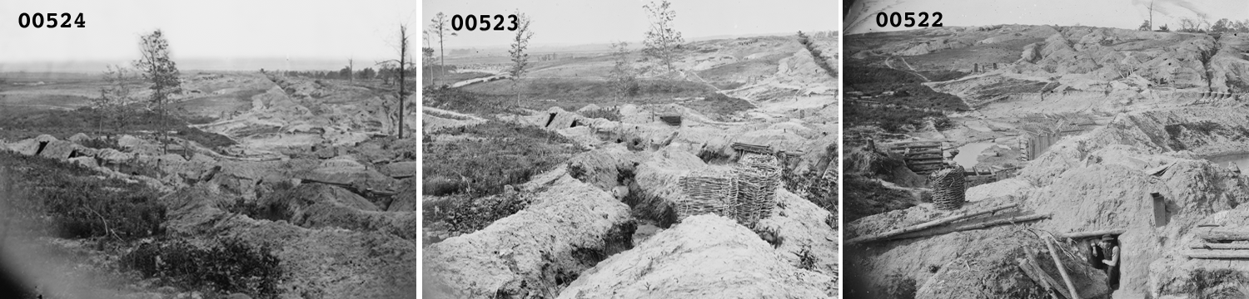

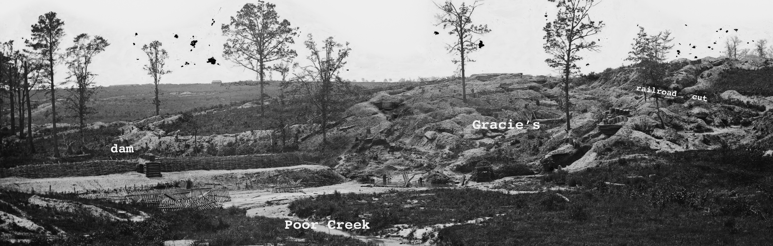
We were able to identify a precise camera location for image 03644, a detail of which is shown below. This image shows the Poor Creek Dam and its gabion traverse from the rear, providing a counterpoint to image 00522. This image provides a collaborative view of the Gracie’s complex as seen from the left front.

Three images (00524, 00528, and 01322/03624) provide broader stereo views of the Gracie’s complex taken from west of the railroad. The subjects of various close-ups of bomproofs (00514, 00520,and 00525) can be identified within these landscape views. O’Sullivan seemed to have a special interest in architectural details. These photos reveal that numerous bombproofs were accessed directly from the railroad cut. Although the railroad does not appear to have been moved, the right-of-way has been widened and perhaps deepened, wiping out adjacent resources.

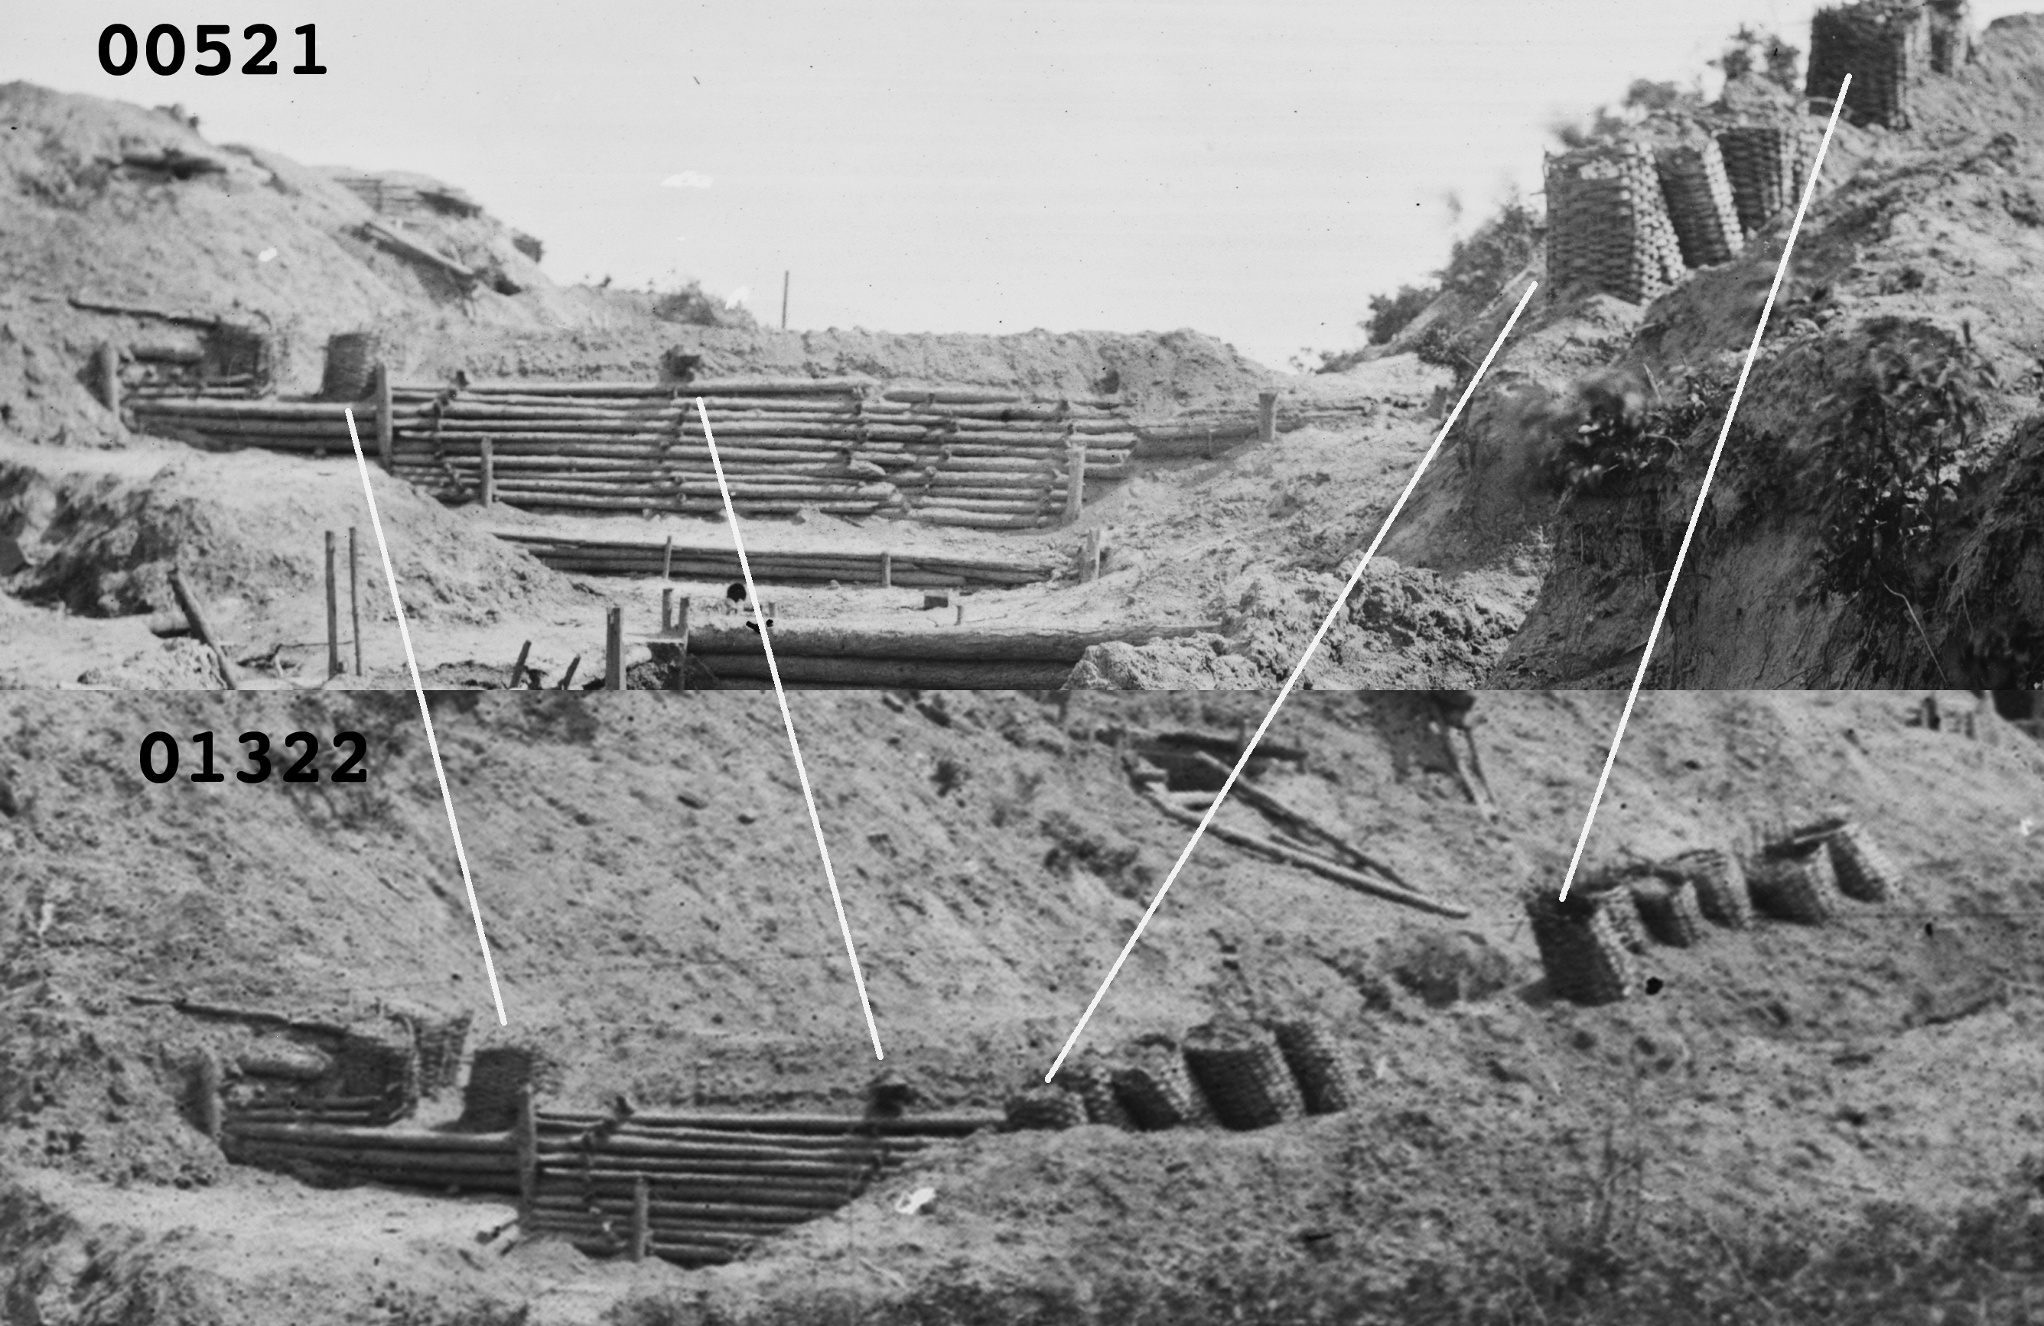
Two stereo images of the same subject in this series (00521 and 00526) have long been misidentified as representing “Fort McGilvery.” These images were taken in the railroad cut behind Gracie’s as is shown by comparing details in this illustration of 00521 (top) with background landscape in 01322 (beneath), which is positively identified as Gracie’s.

In image 00526, O’Sullivan himself emerges from the entrance to a magazine/bombproof with an artillery shell in his hands; in 00521 O’Sullivan has exchanged places with his assistant. The shifting shadows provide a clue on the time of day and sequence of the photos.

